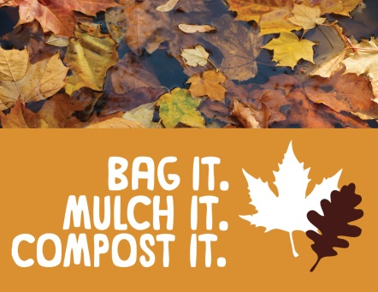
Leaves In Our Community
Coming to a storm drain near you!
Written by Ann Jackson

Leaves-they’re rushing down streets and into storm drains and filling our streams, rivers and the Bay in the kind of quantities Mother Nature never, ever, ever intended them to be!

So what's the big problem? Aren't leaves natural and safe for our waterways?

The answer is yes, they are natural organic matter but organic matter uses up oxygen in the process of decay and contributes to an excess of nitrogen in the water. In fact all dead plant material like fallen leaves use 200% more oxygen when decaying in the water than when decaying on the land. The decay of large quantities of leaves in the water strips large quantities of oxygen out of the water causing fish and other marine life that breath oxygen in the water to suffocate. The unnaturally large quantity of leaves ending up in our waterways occurs because our driveways, sidewalks, streets and storm drains act like superhighways for leaves from our inland trees right to our waterways.

So what can Olde Severna Park residents do?

Getting rid of streets, driveways and storm drains is completely impractical. Killing all the trees that clean our air and provide oxygen to the planet would be totally absurd. The following are all good choices that we can all participate in and feel good about:
- Bag them (paper is preferred) and let the county pick them up. The county will then recycle them.
- Mulch them and use them in your garden. You can use a mulching machine or you can rake your leaves into a pile and run over them with a mower. Leaf mulch is a much better food source for your garden than fertilizer.
- Compost them. If you have the time and space, this is a great way to augment the soil in your garden while recycling both leaves and your fruit/vegetable waste from the kitchen.

However you do it, please help by keeping leaves off your driveways, sidewalks, and streets so that they do not wind up in our storm drains and waterways where they can destroy our local marine life and never, ever, block drainage ditches or curb lines by raking your leaves into them.

Please consider pledging to remove the leaves from hard surfaces around your yard this Fall. It really does make a difference!

Several of your community members will be visiting a few homes near storm drains in the near future. We will have information about pledging to remove leaves from storm drains and hard surfaces around your property and magnets to remind you of what you can do: bag it, mulch it, compost it!

More information about this campaign can be found at the Watershed Stewards Academy website: http://www.aawsa.org/

