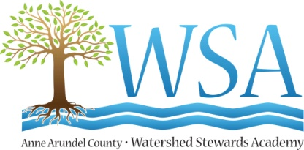

Board of Directors
September 26, 2016
5pm-7pm
Carefree Suites (2830 Solomon’s Island Road)

- Welcome and Celebrations
  - Welcome to Karen Igler!
  - A toast to our amazing progress
    - Board Pledges
    - Major Donor Pledges

- Approval of August minutes

- Treasurer’s Report (Mark)

- Development Update (Bill)

  - Fall Fundraising
    - StewardFest 2016 A kickoff party for our WSA Family at Captain Avery Museum Sunday October 23rd 4pm-6:30pm
    - WSA Green Give Sunday, Oct 23rd 5 p.m.-Monday October 24th 5 p.m.

  - Committee Work and Report Back
    - Green Give and Steward Engagement
    - Conference and Business Engagement
    - Major Donor

- Discussion of Fall Board Dates:
  - Chesapeake Watershed Forum - who is going?
  - October 24
  - November 28
  - Special Budget Session?
  - Next Development Committee Meeting

Adjourn

- Education Committee (Strategic Plan I.4, II.1, II.4, II.5)
  - I.4: Train and empower Stewards to support the Environmental Literacy program of AACPS.
  - II.1: Continually refresh and update the Master Watershed Steward certification and support programs including networking and continuing education.
  - II.4: Pilot new “Steward Lite” programs.
  - II.5: Develop and offer new advanced curricula for veteran Stewards.

- Revenue and Replication (Strategic Plan IV.8, IV.7, IV.9)
  - IV.7: Explore the possibility of taking a leadership role in the replication of WSA in Maryland and beyond and if favorable, create and implement a plan to do so, including raising additional revenue to independently support this initiative.
  - IV.8: Exploration of and action on intellectual property protection.
  - IV.9: Examine training certification options that can be revenue producing.

- Development Committee (Strategic Plan IV.2, IV.6)
  - IV.2: Create and implement a long-range development plan that expands all forms of philanthropy, including support from local businesses.
  - IV.6: Develop capacity to respond to new partnership opportunities while continuing to collaborate with other organizations in Maryland.

